**The control flow digram (CFD)**

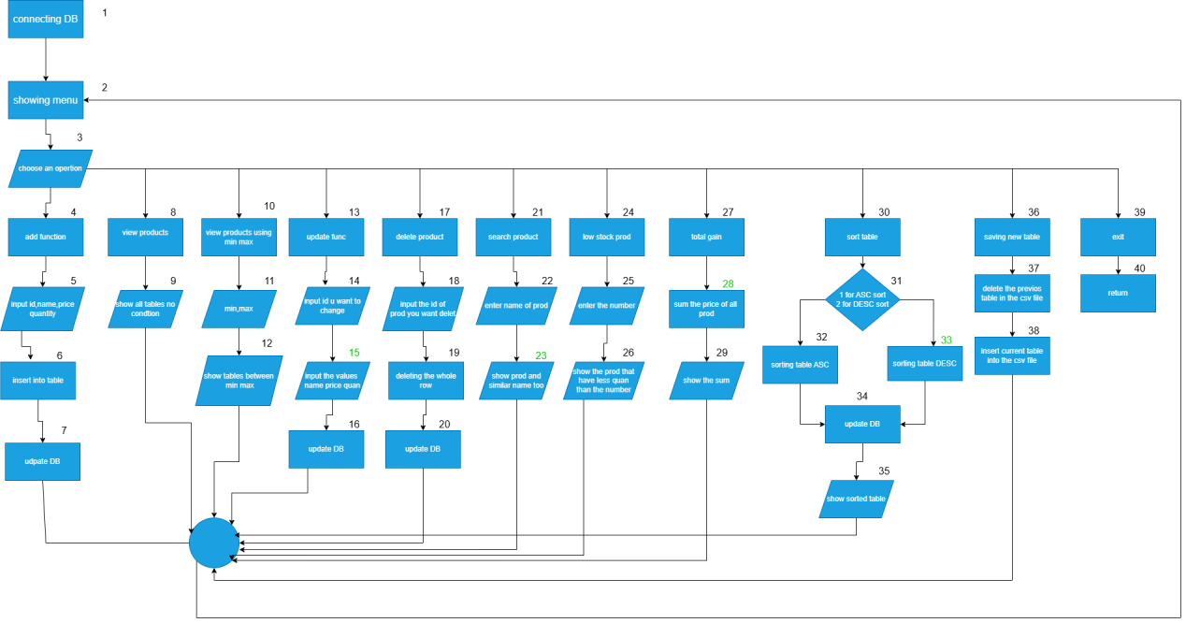

Test case 1

Input:2 |11

Output:the default sort of the table

Test case 2

Input: 3 | 100 |200 |11

Output: the table with only products between 100 and 200

Test case 3

Input:6 | filter |11

Output: the table with only the products which have the word filter in the name

Test case 4

Input:9 | 2 |11

Output:the table sorted descending

Test case 5

Input: 9 |1 |11

Output :the table sorted ascending